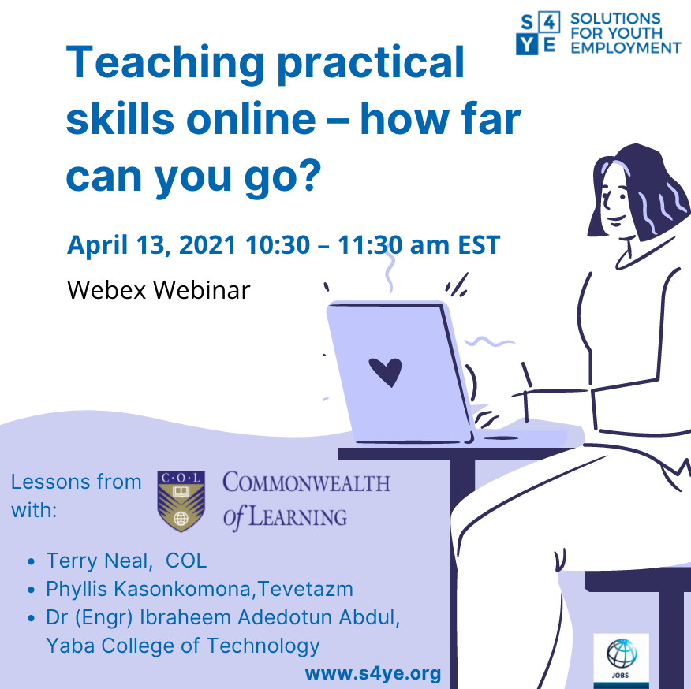

Teaching practical skills online – how far can you go?
LESSONS FROM COMMONWEALTH of LEARNING

Tuesday, April 13, 2021 | 10:30 am – 11:30 am EST

Join Using WebEx

The recording and slides will be available on S4YE website after the session.

Across the world, millions of people, particularly youth are unemployed, with many in developing countries underemployed. At the same time employers struggle to fill jobs as TVET and university graduates do not have the skills they seek. COVID 19 has exacerbated this situation with an estimated half a billion jobs lost during 2020.

The pandemic has also made it more difficult to develop skills. Like other educational institutions, TVET providers have tried to move online. But they face extra challenges with limited technology infrastructure, having a poorer student base less likely to have mobile devices or afford data, reaching youth in more remote locations and the inclusion of practical skills which are hard to teach online.
For more than 30 years, the Commonwealth of Learning (COL) has focused on the potential for open and distance learning to increase access to quality education in developing countries. Even before the pandemic, COL was piloting a model blending online and workplace learning to make TVET more accessible and relevant to help solve the global skills development challenges. However, the pandemic has broadened interest in online methods.
This webinar will share COL’s experiences thus far, including:
- The opportunity to innovate to overcome existing TVET challenges building on decades of experience in Australasia, Africa and Asia,
- COL’s model of online plus workplace learning,
- Lessons from projects that worked on teaching practical skills in trades like construction, woodworking and cell phone repair in Nigeria, Zambia and Tuvalu.

This webinar is part of S4YE’s ongoing learning series that supports youth employment practitioners to share practical insights and learn from one another.

Moderator: Namita Datta, Program Manager, S4YE

Speakers:
- Terry Neal, Education Specialist, Technical and Vocational Skills Development, COL
- Phyllis Kasonkomona, Director Development Division, Technical Education, Vocational and Entrepreneurship Training Authority, Zambia
- Ibraheem Adedotun Abdul, Director, Flexible Skills Development, Yaba College of Technology, Nigeria

Draft Agenda

Time (EST) and length | Who | Content
10:30 – 10:35 | Namita | Introduction to the webinar and the speakers
10:35 – 10:55 | Terry | - COL’s blended TVET model and how it increases access through greater affordability and flexibility.  - Lessons learnt from three projects thus far
10:55 – 11:02 | Dotun | - TVET institution perspective, Nigeria
11:02 ‒11:09 | Phyllis | - Government perspective, Zambia
11:09‒11:25 | Namita | Q &A session
11:25 | Namita | Closing summary

Speakers’ Bios:

Terry Neal

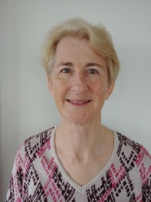
Terry joined COL as Education Specialist: TVSD in October 2018. She has a diverse range of experience internationally, nationally and institutionally related to skills development. For more than 20 years, she has worked with governments, formal tertiary vocational institutions, industry training organizations, community education providers, schools and private companies to enable innovative approaches that harness the potential of open, distance and technology-based learning for TVET.

Phyllis Kasonkomona

Phyllis has vast experience in TEVET sector spanning over 20 years. She is currently working as Director -Development for TEVETA where her main role is to oversee research and development of training systems and curricula to support technical education, vocational and entrepreneurship training.
She holds a Master of Arts in Technical and Vocational Education and Bachelor of Arts in Technical and Vocational Education from Bolton University-United Kingdom. She also holds a Bachelor of Business Administration & Entrepreneurship from Mulungulushi University-Zambia where she graduated as the best student.

Ibraheem Adedotun Abdul

Ibraheem works with Yaba College of Technology, Lagos, Nigeria as the Director, Flexible Skills Development Centre. He has over 25 years of experience working in a TVET institution and championing innovative trainings and skill development programs across the country. His passion for youth development and innovation makes him involve in several development initiatives targeted at empowering youths and leveraging distance, flexible and online learning to deliver skills training in Nigeria.

About Commonwealth of Learning

The Commonwealth of Learning (COL) is an intergovernmental organization created by Commonwealth Heads of Government in 1987 to promote the development and sharing of open learning and distance education knowledge, resources and technologies. COL supports efforts to provide Commonwealth citizens greater access to quality education and training through open, distance and technology-enabled learning, thereby allowing them to benefit from improved livelihoods, greater gender equity and overall economic, social and cultural development leading to sustainable development.

About Solutions for Youth Employment (S4YE):
S4YE is a multi-stakeholder coalition that aims to provide leadership and resources for catalytic action to increase the number of young people engaged in productive work. It is a global program housed in the Jobs Group of the Social Protection and Jobs Global Practice. It consists of a network of over 35 private companies (Private Sector Advisory Council), a network of 44 high-potential and innovative youth employment projects (Impact Portfolio), a group of 17 talented and enterprising global youth (Youth Advisory Group) that provide youth voice on the design of youth employment programs of S4YE and the World Bank and has a network of 150 World Bank youth employment projects in 69 countries.

The S4YE coalition’s founding members include the World Bank, Accenture, The Rockefeller Foundation, Mastercard Foundation, Microsoft, Plan International, International Youth Foundation (IYF), Youth Business International (YBI), RAND Corporation, the International Labour Organization (ILO), the Governments of Norway and Germany, and the UN Office of the Secretary-General’s Envoy on Youth.

The S4YE webinar series attempts to share new ideas and potential solutions with our network. Partners/teams should follow their internal due diligence processes in finding the best fit for their requirements.
https://www.s4ye.org/| info@s4ye.org | SolutionsforYouthEmployment | @S4YE_Coalition

