Personal Information
By providing your information below, you agree to give permission to UNESCO to store your data strictly for the purpose of the competition and for subsequent attribution of your photo(s).

Last name: Click or tap here to enter text.
First name: Click or tap here to enter text.
Postal address: Click or tap here to enter text.
Country: Click or tap here to enter text.
Gender: Click or tap here to enter text.
Age: Click or tap here to enter text.
Date of birth: Click or tap here to enter text.

Contact Details
By providing the information below, you agree to give permission to UNESCO to (i) contact you for the purpose of the Skills in Action Photo Competition and (ii) to share your contact details to its affiliate entities shall there be any interest to independently commission you in the form of, but not limited to, engaging you as a photographer or purchasing items of your work.

E-mail*: Click or tap here to enter text.
Tel. no: Click or tap here to enter text.
Mobile no*: Click or tap here to enter text.

Entries
Title of the photo | Description (not more than 75 words) | Location and date photo was taken | Indicate digital manipulation (if any)

Do not forget to attach the original photos to your email. You may also want to zip the files before attaching.

I hereby acknowledge that I have read and understood the Terms and Conditions as provided herewith and as stated regarding participation in the Skills in Action Photo Competition organized by UNESCO-UNEVOC. I also certify that all the information submitted in this form is true and accurate.
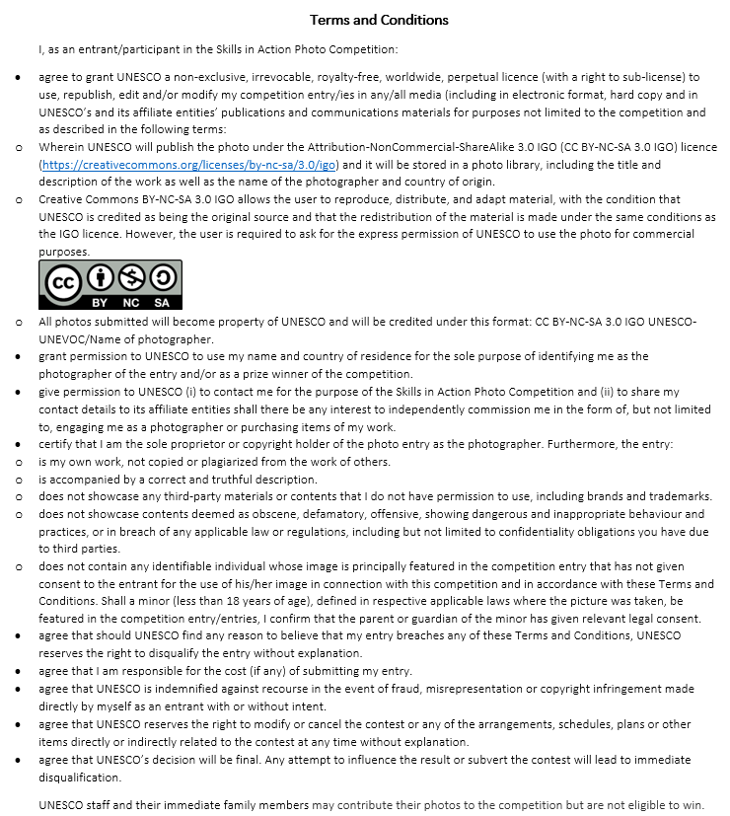
I hereby agree with the Terms and Conditions as specified above for participation in the Skills in Action Photo Competition 2022.
________________________________ ____________________________
Name (in block letters) Date and signature

